Dockerized Flask web application using AWS services

Below is a complete beginner-friendly, end-to-end DevOps project using the latest AWS Console that automates build & deployment of a Dockerized Flask web application using:
- GitHub (source code)
- AWS CodePipeline (CI/CD orchestration)
- AWS CodeBuild (build Docker image)
- Amazon ECR (Docker image registry)
- Amazon ECS (Fargate) (container orchestration)
- IAM (permissions)
You will deploy a Flask web app that serves:
- index.html
- style.css
- javascript.js
Step 1: Create Flask Web Application
- app.py
- requirements.txt
- Dockerfile
- buildspec.yml
- templates/index.html
- static/style.css
- static/javascript.js
Step 3: Create Amazon ECR Repository (Manual)
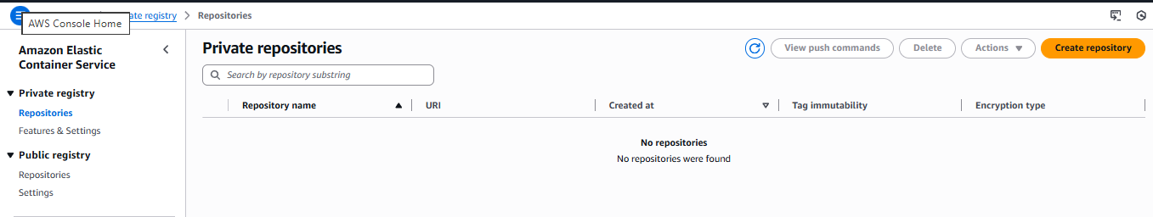
- AWS console ECR Private Registry Create repository

- Repository name : ecr-web-app
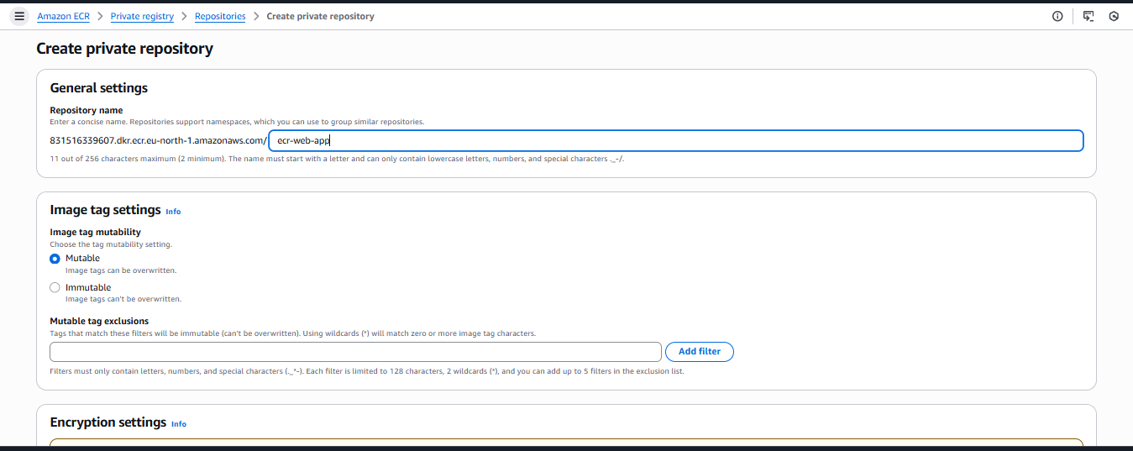

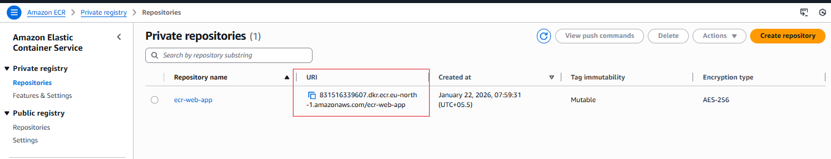
- Click Create

- Example ECR URI : <Copy ECR URI>
Step 4: IAM Roles (VERY IMPORTANT)
4.1 CodeBuild Role
- Create IAM Role:
- Service: CodeBuild
- Permissions:
- AmazonEC2ContainerRegistryPowerUser
- AmazonS3ReadOnlyAccess
- CloudWatchLogsFullAccess
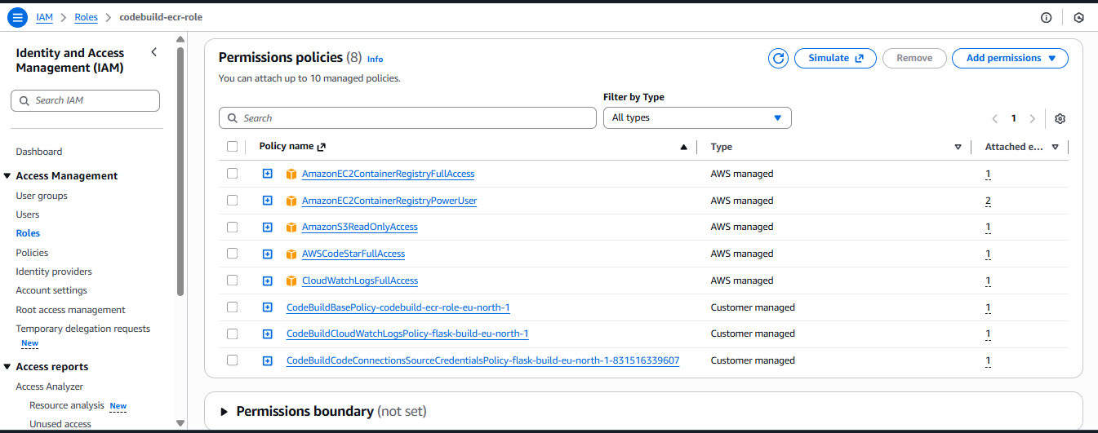

- IAM Name: codebuild-ecr-role

4.2 ECS Task Execution Role
a. Create IAM Role:
b. Service: ECS Task
c. Policy:
- AmazonECSTaskExecutionRolePolicy
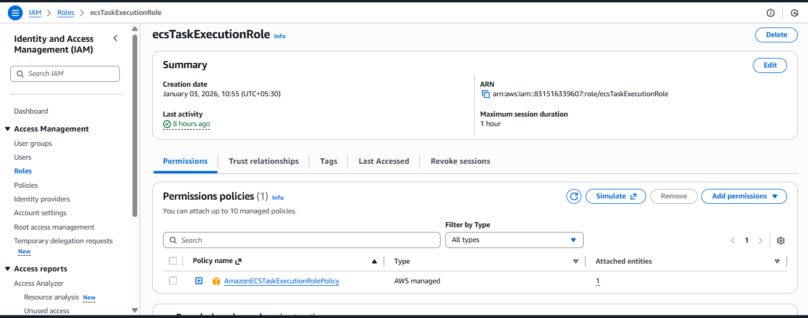

d. IAM Name: ecsTaskExecutionRole

Step 5: buildspec.yml (CI Logic)
- AWS_resource/buildspec.yml
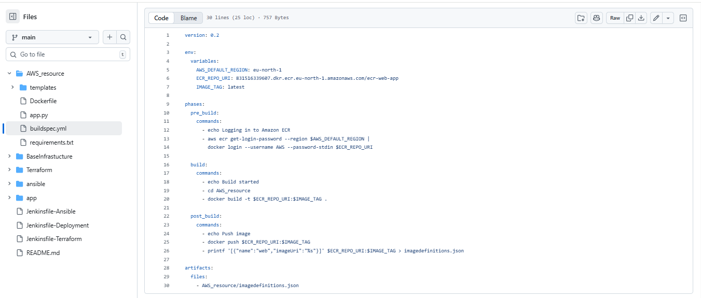

\

Step 6: Create ECS Cluster (Fargate)

- AWS console Amazon ECS Clusters Create Cluster
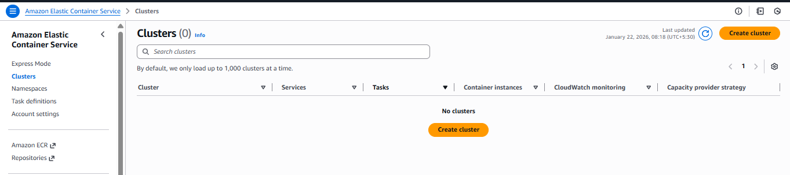

- Create Cluster Cluster configuration Cluster Name Infrastructure Fargate Only Click create
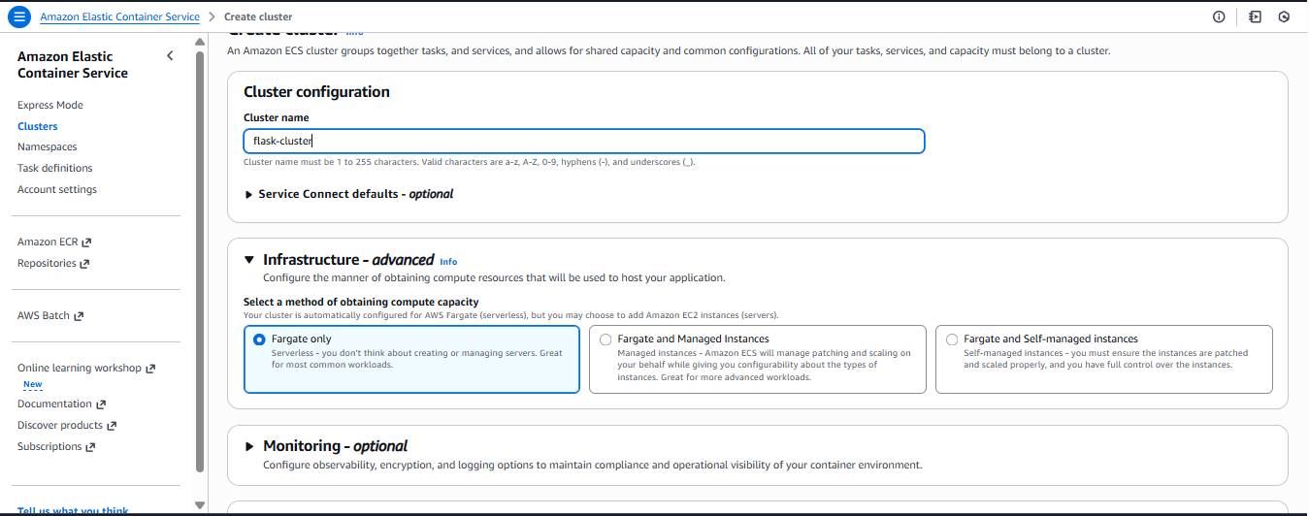

- ECS Cluster Name : flask-cluster
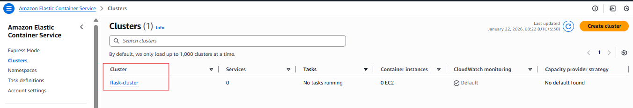

Step 7: Create Task Definition

- Amazon ECS → Task Definitions → Create
- Task Definitions Name : flask-task
- Infrastructure requirements : launch type AWS Fargate
- OS, Architecture, Network mode : linux/x86_64
- CPU : .25 vCPU & Memory : .5 GB
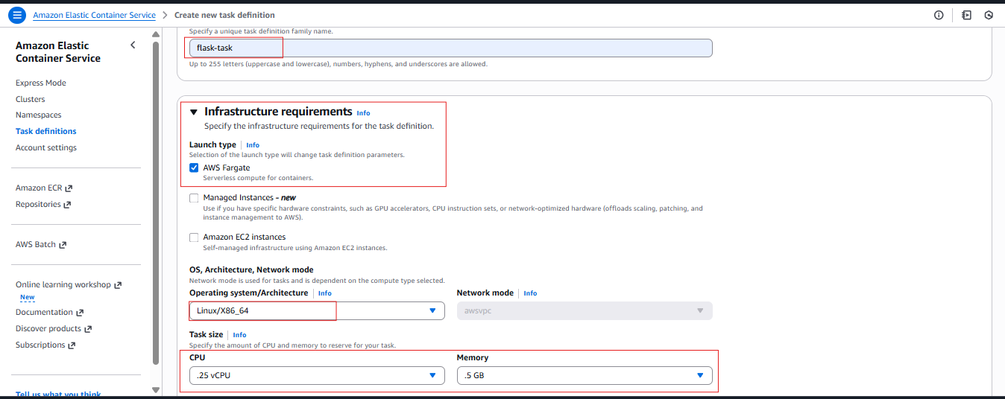

- Add Task Role : ecsTaskExecutionRole
- Container 1 : -
- Name : web
- Image URI : <Amazon ECR URI of ecr-web-app>
- Port Mapping :-
- Container port : (<Your application port like I use python so my port is 5000>)
- Port name : Flask-container-port-5000
- Click Create
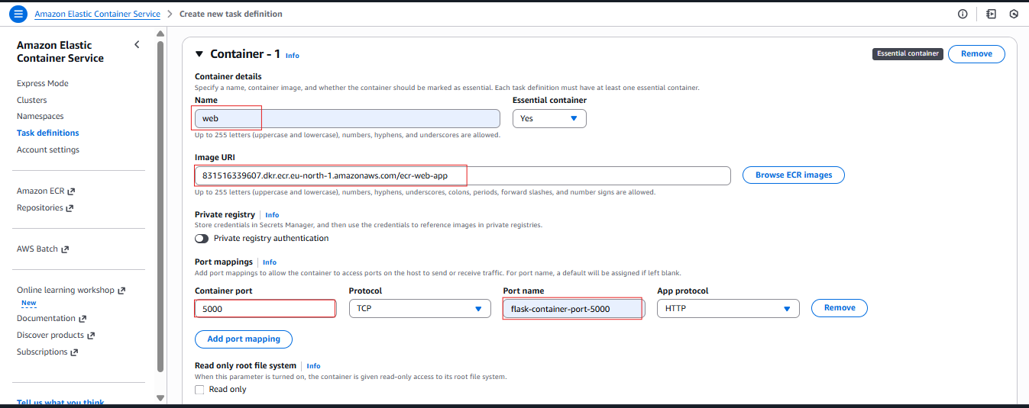

Step 8: Create ECS Service

- Amazon ECS Clusters flask-cluster services click create
- Create Service Select Task Select Version Service name rest of all default Create
- We will use Load Balancer Later.
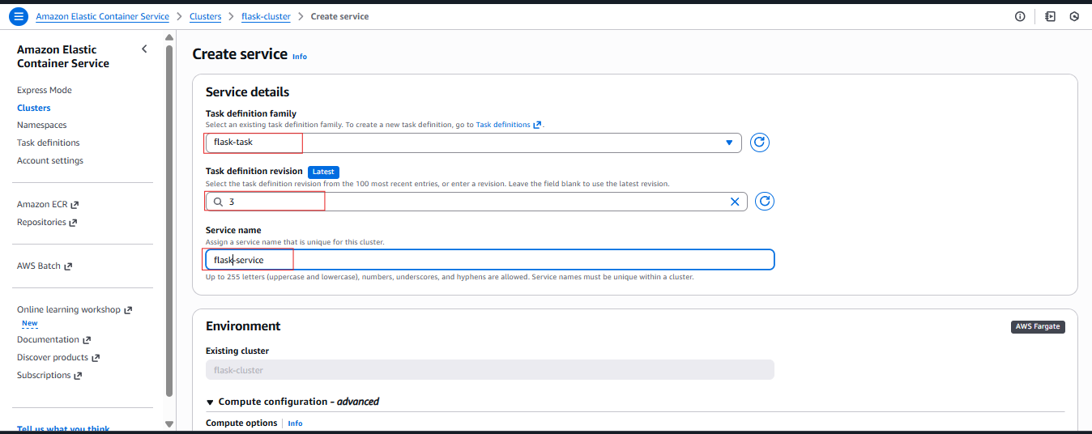

Step 9: Create CodeBuild Project

- AWS console Codebuild Build projects Create Project
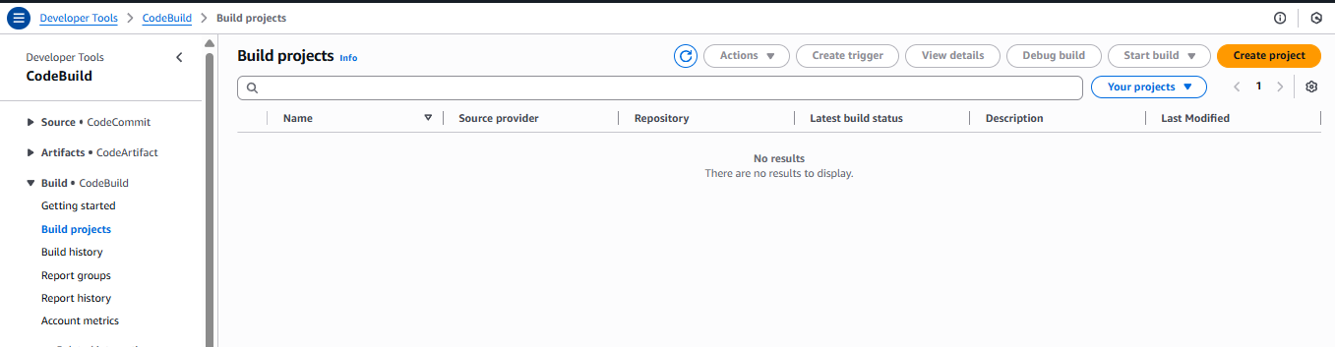

- Create build project Project configuration flask-build project type Default
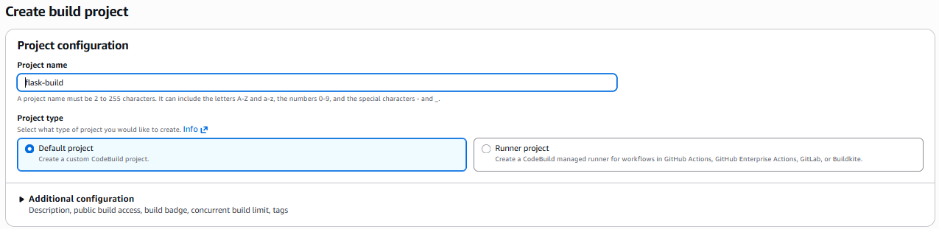

- Source 1 - primary Github Connect via Credential select your repository

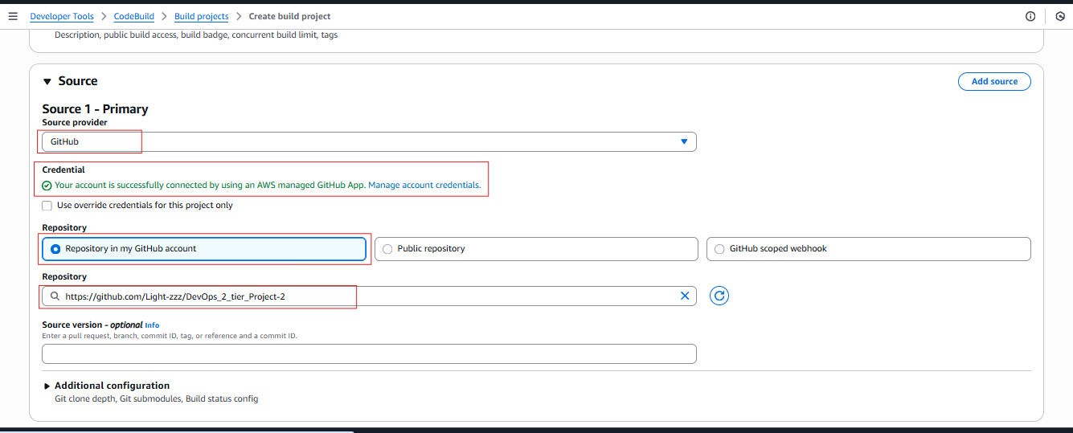

- Default of Primary source webhook events
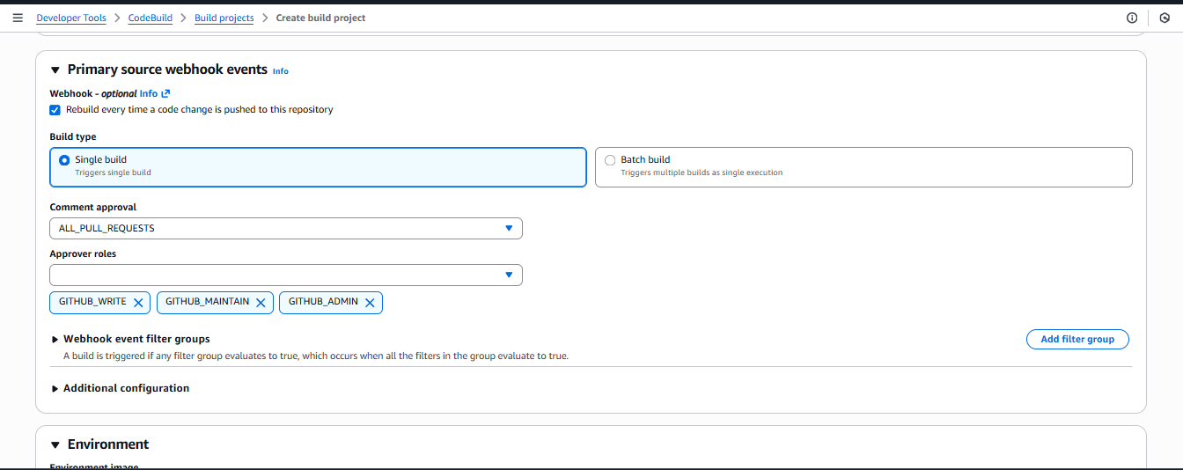

- Environment Environment image : Managed image Running Mode : Container
- Operating System : Amazon linux
- Runtime : Standard
- Image : aws/codebuild/amazonlinux-x86_64-standard: 5.0
- Image Version : Always use the latest image for this runtime version
- Service role : Existing role codebuild-ecr-role
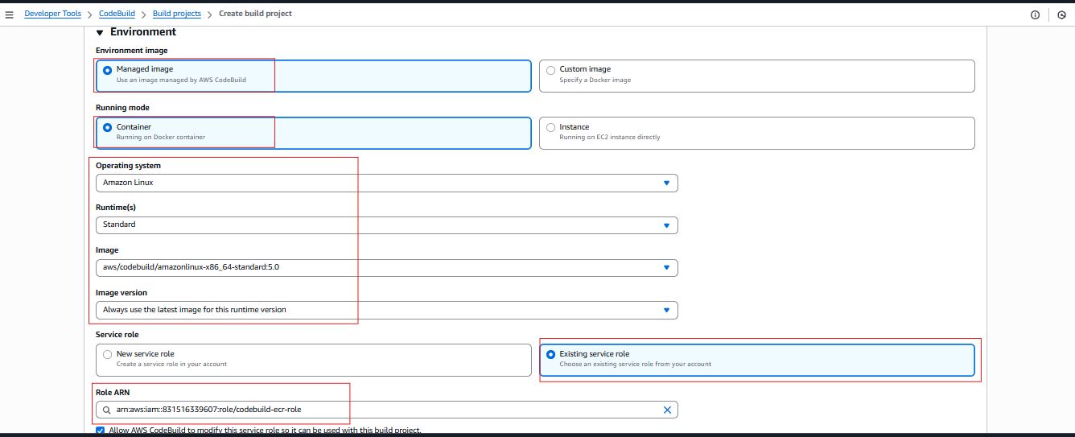

- Buildspec Use a buildspec file
- Buildspec name : AWS_resource/buildspec.yml

- Click Create Build project
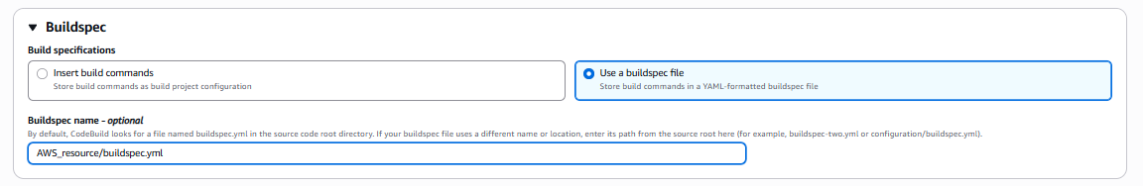

- Click Start Build to test the buildspec.yml
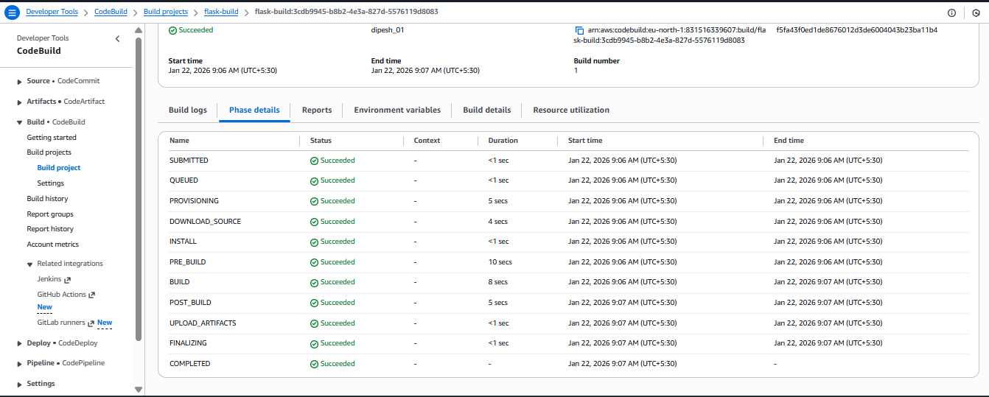

- Go to Amazon ECR and check the Repository
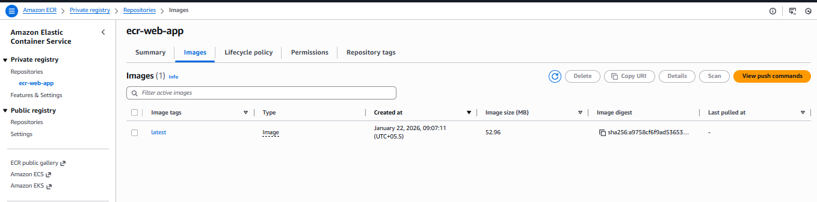

NOTE ⚡ : Step 10: Recreate the cluster Service
Below Creating Cluster Service 1st Create CodeBuild and run manually to push the image into Amazon ECR.
After Create the Amazon ECS Cluster Service and wait to running of Service and Tasks.
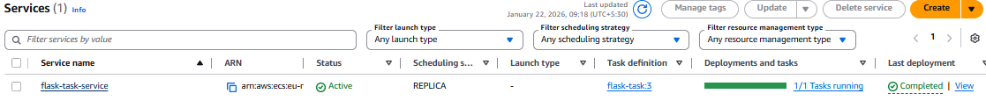

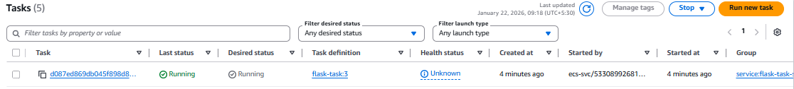

Step 11: Create CodePipeline (Automation)

- AWS Console CodePipeline Pipelines Create Pipeline
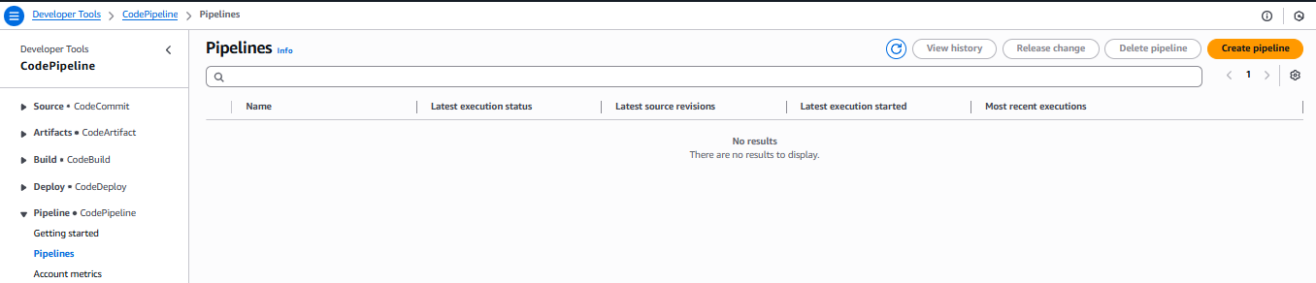

- Choose Creation option : Build custom pipeline Next
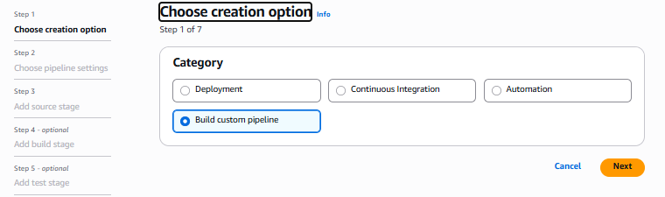

- Choose Pipeline Settings Pipeline name : flask-pipeline Service role : Existing role (if you created) Role ARN : select your ARN Next
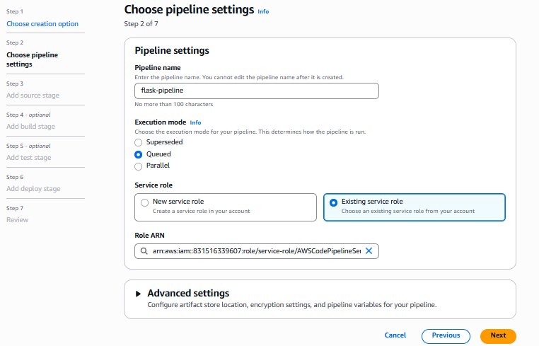

- Source Stage Source provider : GitHub connection Repository name Select Branch Next
If error in source to connect than use [GitHub OAuth].
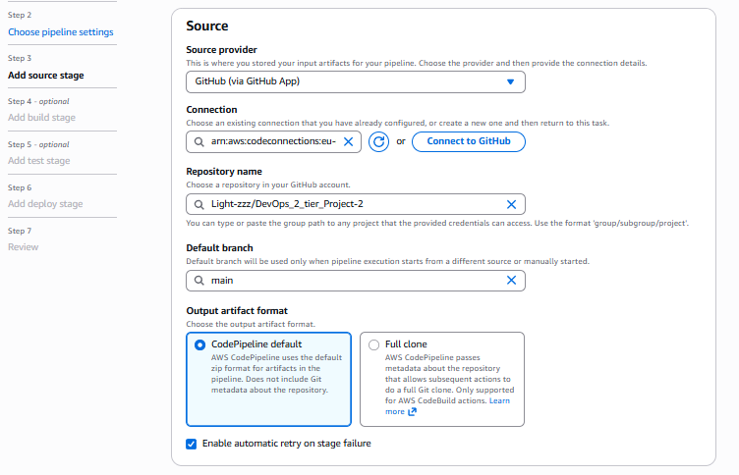

- Build Stage Other build providers : AWS Codebuild Project name : flask-build Next
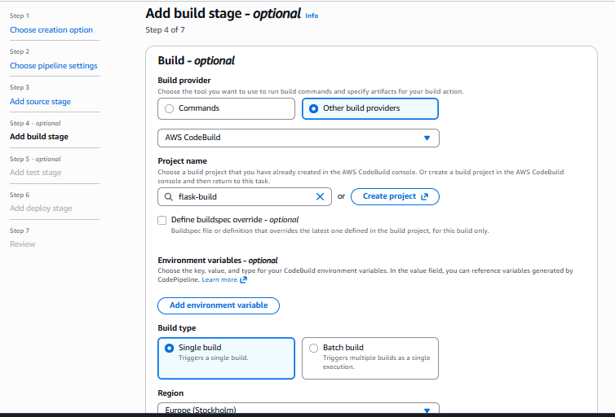

- Deploy Stage Deploy : Amazon ECS Region : your region Cluster name : flask-cluster Service name : flask-task-service Image definitions : AWS_resource/imagedefinitions.json Next
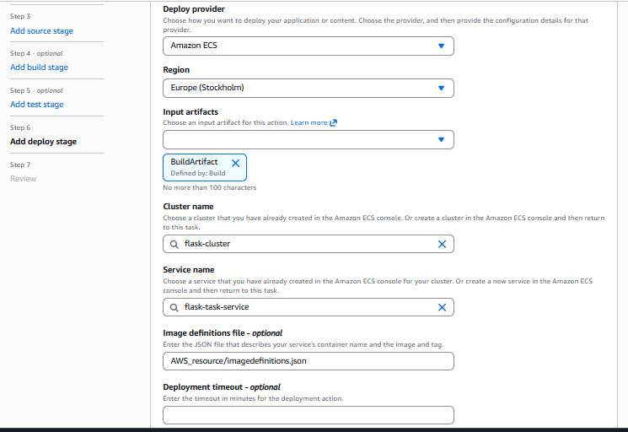

- Review all the stages click Create Pipeline

- Check the flask-pipeline is working or not
AWS console Codepipeline Pipelines Flask-pipeline.
